Carers Count...
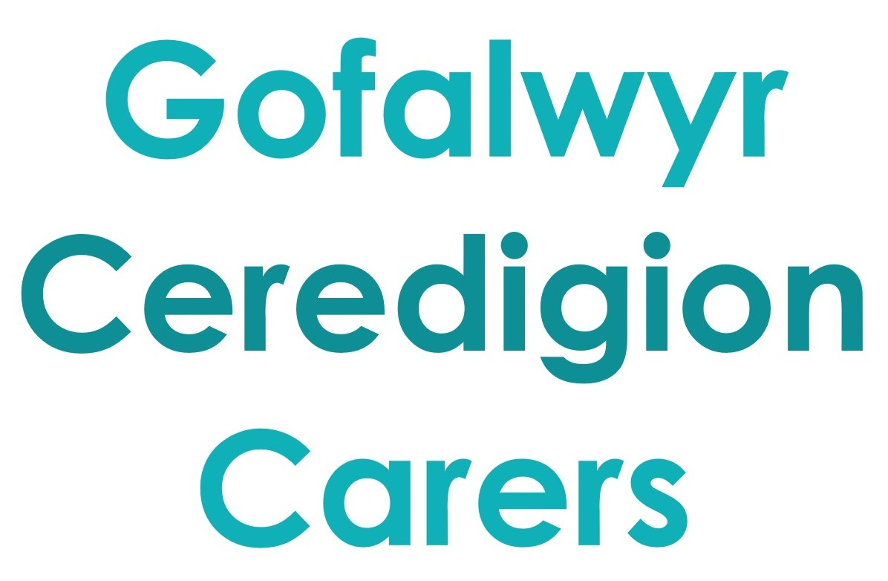

Count me in!
Do you look after a relative or friend?

If you provide support to someone who is ill, has a disability,
learning disability, mental health or substance misuse problem and that person cannot manage without your help, then you are a CARER.
Carers can be relatives, Parents, young people, friends or neighbours.

Credu is part of a group of organisations (Gofalwyr Ceredigion Carers) committed to providing information, advice and replacement care to Carers across Ceredigion.

Joining Gofalwyr Ceredigion Carers is FREE and you can sign up for news & information or direct support including respite. You can sign up by completing this form, calling 03330 143377 or email ceredigion@credu.cymru

You can also find out more by visiting our website www.gofalwyrceredigioncarers.cymru, by liking our Facebook page ‘Gofalwyr Ceredigion Carers’ or by following our Twitter account @GofalwyrC

First Name…………………………………………..………Surname………………………………………………………….………….
Date of Birth……………………………. Phone Number(s)………………………………………………………………………….
Address……………………………………………………………………………………………………………………………………………………………………………………………………………………………………………. Postcode………………………………...……..
E-mail: ………………………………………………………..…………………………………………………………………………………..
Where did you see this form?...............................................................................................................
Brief description of your caring role ………………………………………………………………………………………………..
…………………………………………………………………………………………………………………………………………..……………
………………………………………………………………………………………………………………………………………………………..
YES! I would like Someone to call me about supporting me

To receive news and information In the post By email

Signed …………………………………………………………………………………………. Date………………………….

Return to: FREEPOST CREDU (no stamp or other details needed)

Credu takes your privacy seriously and we will use your personal information to enable us to support you and monitor the difference we make. Your personal information may be shared with your Local Authority (council) and NHS as a ‘public task’.
We may suggest other organisations and services that could support you, but will only pass on your information to these with your permission, unless someone may be at risk.
For further information about how we process personal data, your data protection rights or to complain about how we handle your information please visit www.credu.cymru/privacy or contact Laura Hammond at laura@credu.cymru or 03330 143377.
Registered Charity Number 1103712, Company Reg. No. 4779458 Registered in Wales.
Credu is a Network Partner of Carers Trust

EQUALITY MONITORING
Would you mind if we record Equality Monitoring Information? PREFER NOT TO COMPLETE
How would you describe ETHNIC BACKGROUND?
Prefer Not to Say
White
English/Scottish/Welsh/Northern Irish/UK
Irish
Gypsy or Irish Traveller
Any other white Background
Mixed ethnic Background
Asian/Asian UK
Indian
Pakistani
Bangladeshi
Chinese
Any other Asian background
Black / African / Caribbean / Black UK
African
Caribbean
Any other Black / African / Caribbean
Other ethnic group
Arab
Other
Would Carer describe themselves as Disabled? Prefer Not to Say / YES / NO
RELIGION OR BELIEF
Prefer Not to Say
No Religion
Christian
Buddhist
Hindu
Jewish
Muslim
Sikh
Other religion
SEXUAL ORIENTATION
Prefer Not to Say
Heterosexual
Lesbian, gay men or bisexual

